Peterson’s solution
Peterson’s solution is a software-based solution to the critical section problem for only two processes. This allows two processes to execute concurrently without letting more than one process to be in its critical section.

If turn ==I P_{i}
Flag array
The code for the critical section problem will be:
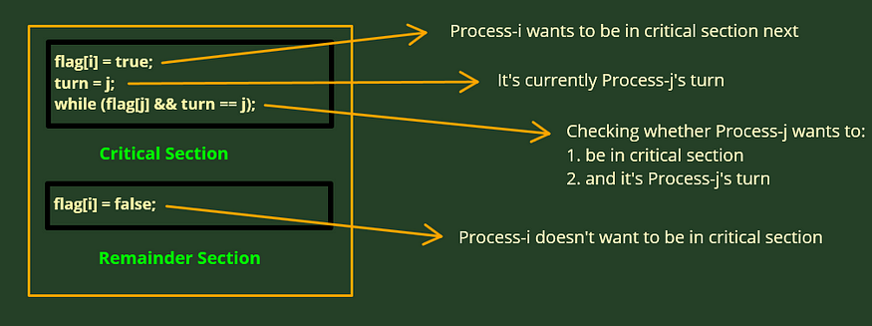
Peterson’s Solution Psuedo Code explained
Let’s try to understand this algorithm with the help of an example, where two processes are trying to execute concurrently while sharing some global data:
Example
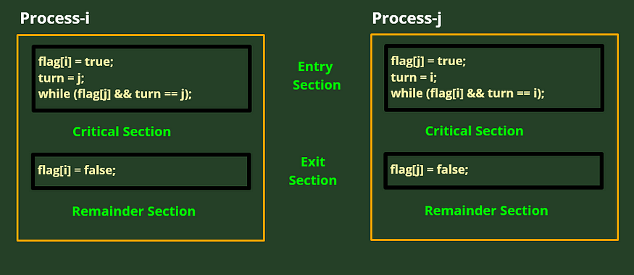
Two processes implementing Peterson’s Solution

Explanation
The above example has two processes Pi and Pj executing concurrently in a single processor system.
The process desiring to get to the critical section will let the other process to go to the critical section, by assigning the process to the turn variable.
The main part of the Peterson’s solution is the while loop statement. Note that the while loop has a semi colon at the end, which means if the while has true, it will keep executing and won’t let the process to be in its critical section, and will let the other process to go to the critical section.
In the exit section, the process is releasing the critical section by assigning its flag to false.
Note that, the exit section is involved in the while loop condition of each process.
Checking the 3 Conditions
· Mutual Exclusion — is satisfied by the while loop.
· Progress — is also satisfied as any process requesting for critical section will get it when no other process is in its critical section, as the while loop is always waiting for any process.
· Bounded Wait — Bounded wait is also satisfied, as we are pointing our flag to false at the end of a critical section.
Example of Peterson’s Algorithm
Peterson’s solution is often used as a simple example of mutual exclusion in concurrent programming. Here are a few scenarios where it can be applied:
- Accessing a shared printer: Peterson’s solution ensures that only one process can access the printer at a time when two processes are trying to print documents.
- Reading and writing to a shared file: It can be used when two processes need to read from and write to the same file, preventing concurrent access issues.
- Competing for a shared resource: When two processes are competing for a limited resource, such as a network connection or critical hardware, Peterson’s solution ensures mutual exclusion to avoid conflicts.

Here’s how Peterson’s Algorithm works step-by-step:
- Initial Setup: Initially, both processes set their respective flag values to false, meaning neither wants to enter the critical section. The turn variable is set to the ID of one of the processes (either 0 or 1), indicating that it’s that process’s turn to enter.
- Intention to Enter: When a process wants to enter the critical section, it sets its flag value to true signaling its intent to enter.
- Set the Turn: Then the process, which is having the next turn, sets the turn variable to its own ID. This will indicate that it is its turn to enter the critical section.
- Waiting Loop: Both processes enter a loop where they check the flag of the other process and the turn variable:
  - If the other process wants to enter (i.e., flag[1 - processID] == true), and
  - It’s the other process’s turn (i.e., turn == 1 - processID), then the process waits, allowing the other process to enter the critical section.
This loop ensures that only one process can enter the critical section at a time, preventing a race condition.
- Critical Section: Once a process successfully exits the loop, it enters the critical section, where it can safely access or modify the shared resource without interference from the other process.
- Exiting the Critical Section: After finishing its work in the critical section, the process resets its flag to false. This signals that it no longer wants to enter the critical section, and the other process can now have its turn.
By alternating turns and using these checks, Peterson’s algorithm ensures mutual exclusion, meaning only one process can access the critical section at a time, and both processes get an equal opportunity to do so.

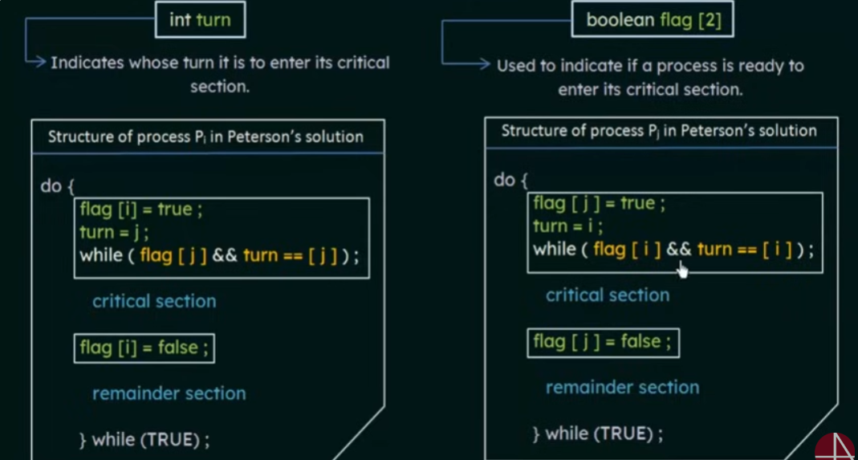

https://www.youtube.com/watch?v=gYCiTtgGR5Q

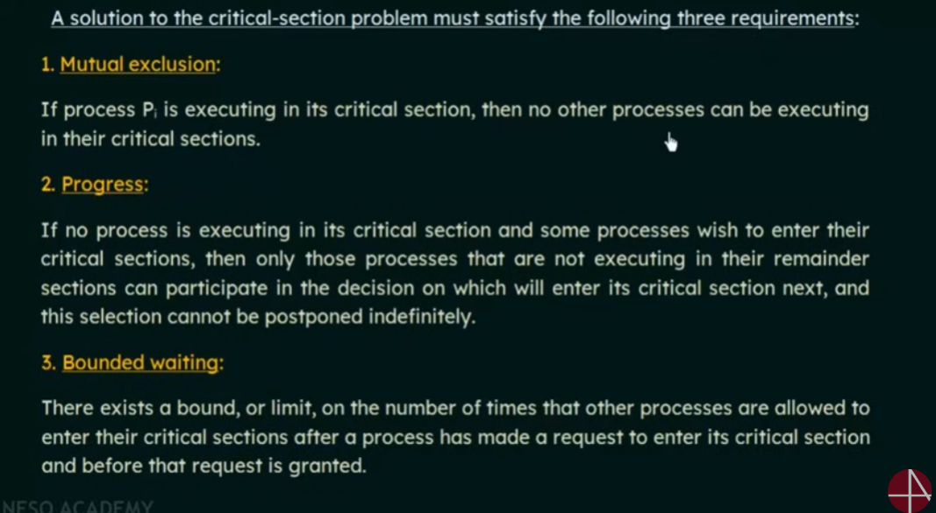

https://www.youtube.com/watch?v=5oZYS5dTrmk
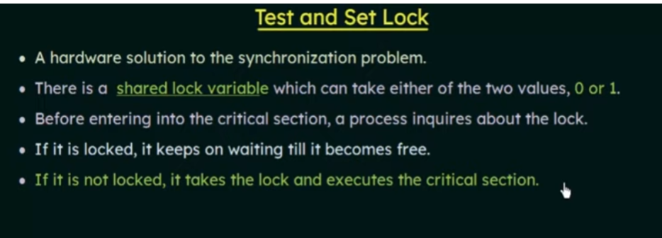

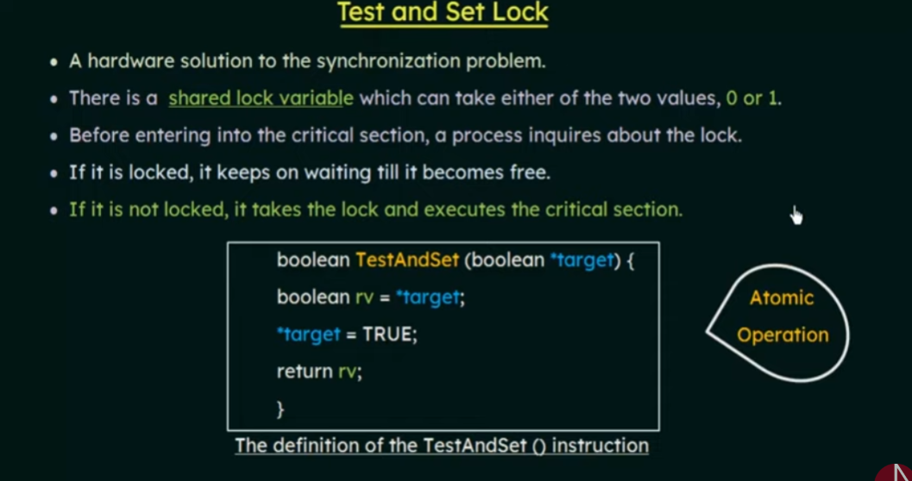

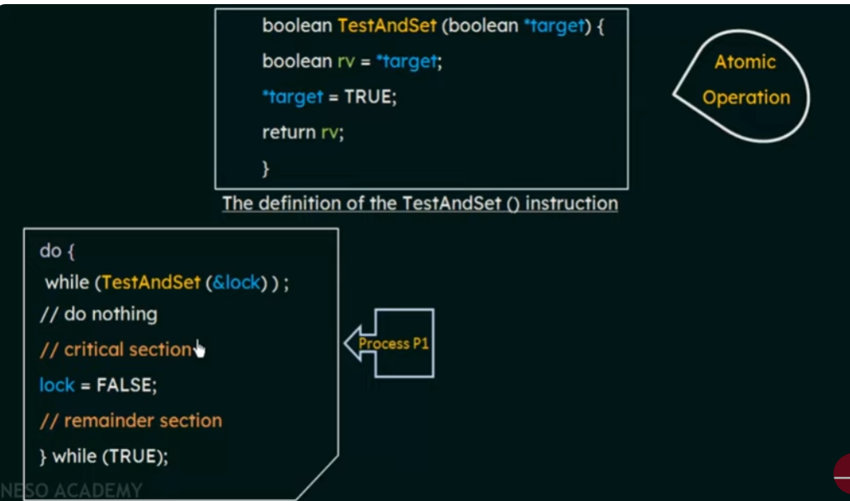

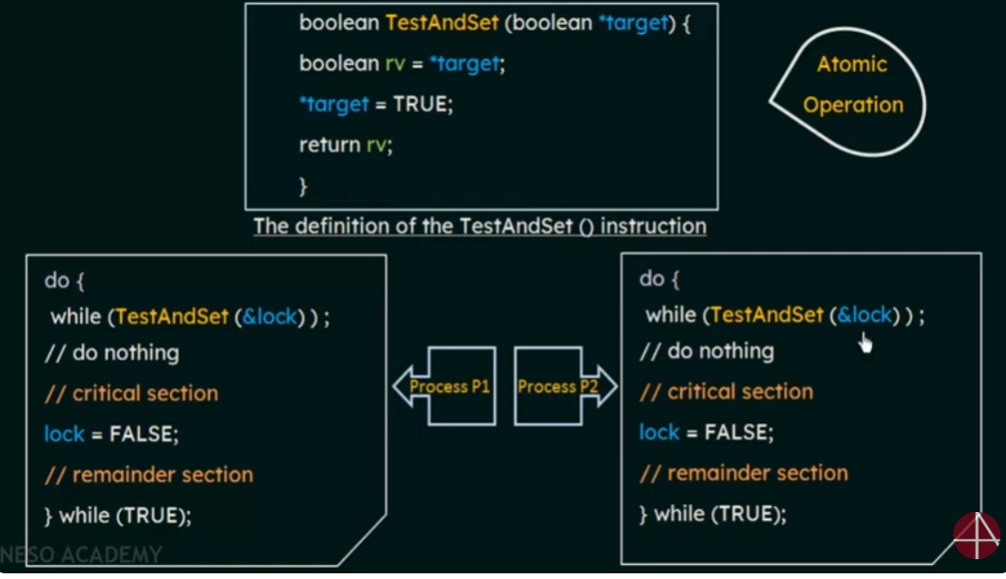

Hardware Instruction (Compare and Swap operation)

The compare and swap() instruction (CAS), just like the test and set() instruction, operates on two words atomically, but uses a different mechanism that is based on swapping the content of two words.
The CAS instruction operates on three operands and is defined in Figure 6.7.
The operand value is set to new value only if the expression (*value == expected) is true.
Regardless, CAS always returns the original value of the variable value.
The important characteristic of this instruction is that it is executed atomically. Thus, if two CAS instructions are executed simultaneously (each on a different core), they will be executed sequentially in some arbitrary order. Mutual exclusion using CAS can be provided as follows: A global variable (lock) is declared and is initialized to 0. The first process that invokes compare and swap() will set lock to 1. It will then enter its critical section,

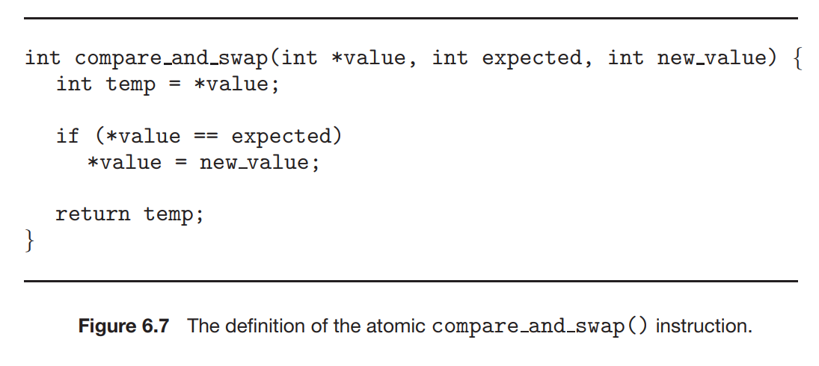
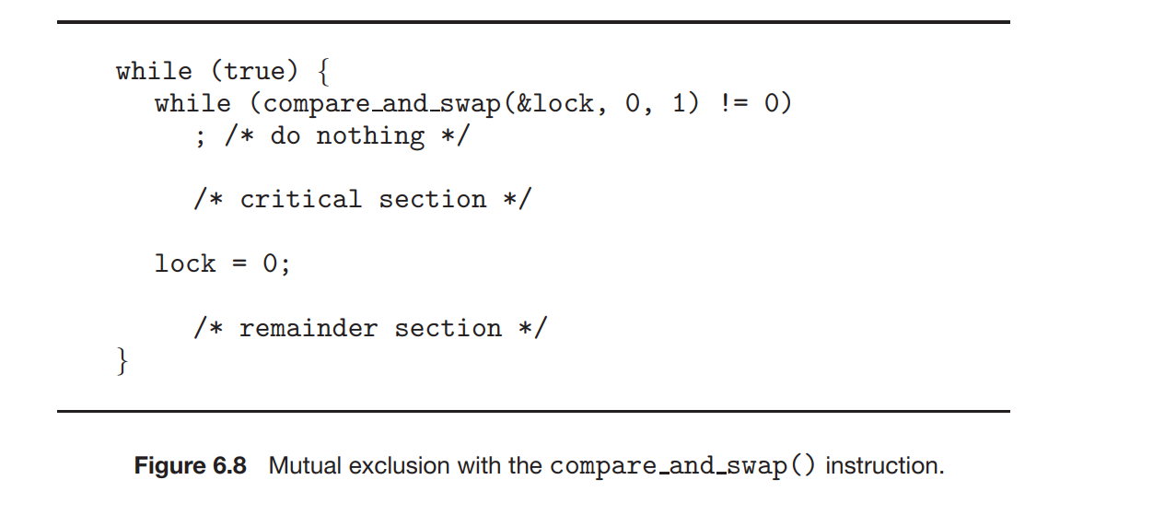

Atomic Process
Atomic operations in Operating System are those operations, which execute without interruption of any other process in between their execution phase. They execute at the lowest level and can’t be broken down further. Formally, when an atomic operation is in its executing process, no other process can read, modify, or interrupt that operation’s data.
In process synchronization, a "process" is considered "atomic" when it executes completely without interruption from any other process, meaning the entire operation happens as a single, indivisible unit, preventing any other process from accessing or modifying the shared data during its execution; essentially, it guarantees that the operation is fully completed before another process can start accessing the same data, thus avoiding race conditions.
Key points about atomic processes:
- No Interruptions:
An atomic operation cannot be interrupted by any other process while it is running.
- Critical Sections:
Atomic operations are often used to protect critical sections of code where shared data is accessed, ensuring only one process can modify the data at a time.
- Hardware Support:
Many modern processors provide hardware instructions that are inherently atomic, allowing for efficient implementation of atomic operations.
Example:
- Imagine updating a bank account balance: If the "withdraw" operation is atomic, the process of reading the current balance, subtracting the withdrawal amount, and updating the balance happens as a single, uninterrupted step, preventing another process from accessing the account during the update and potentially causing inconsistencies.

Mutex Lock
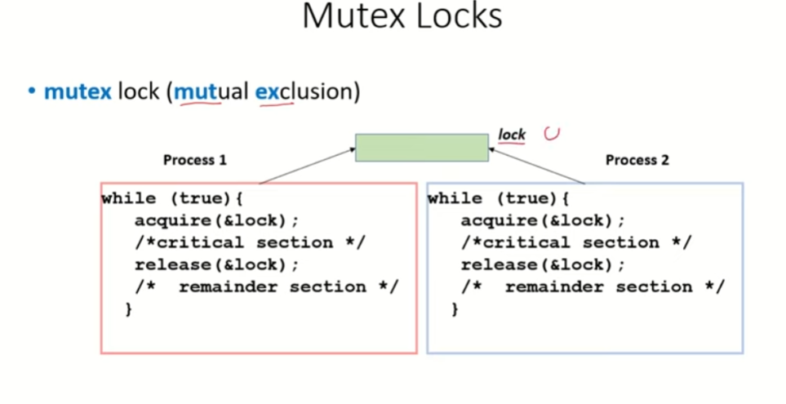

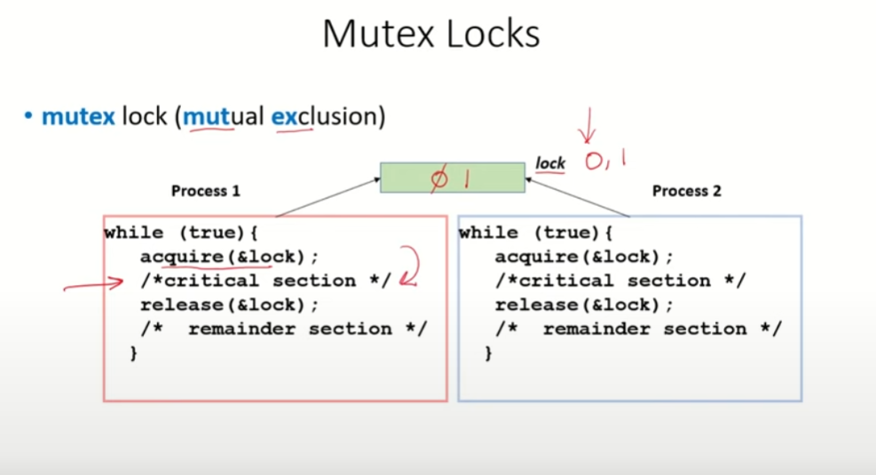

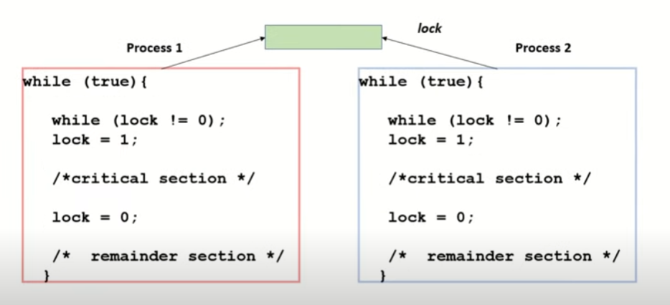

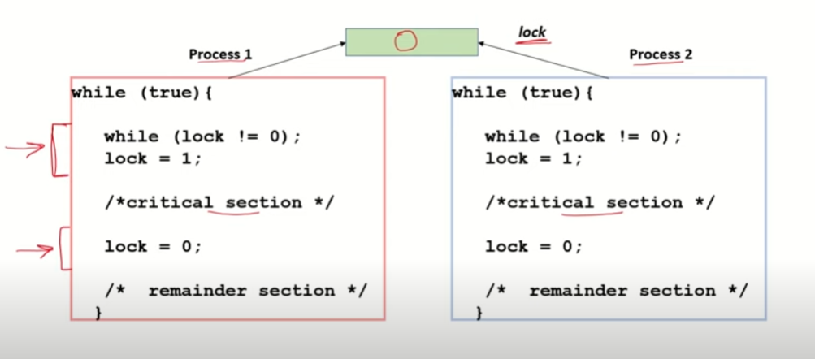

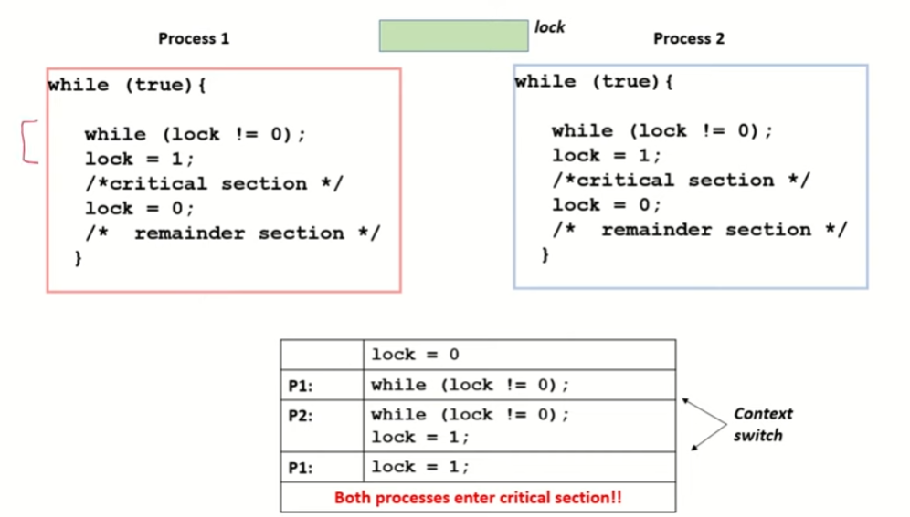

When Process is atomic then the property of mutual exclusion is maintained.
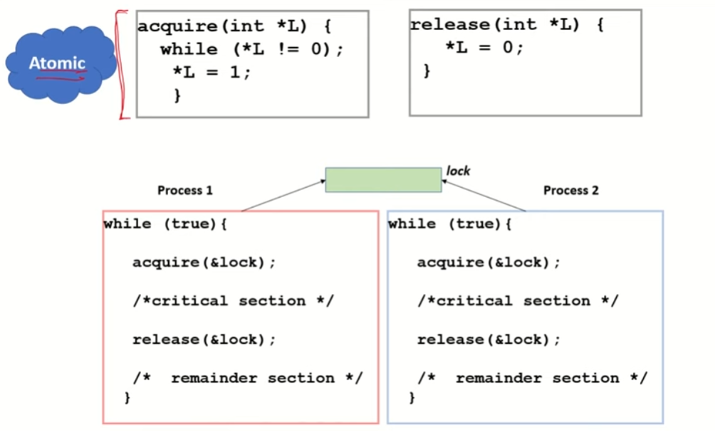

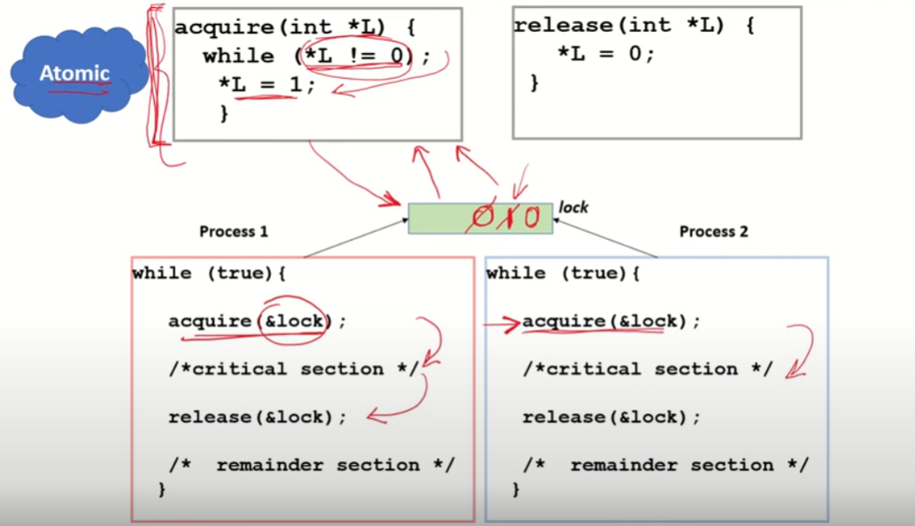

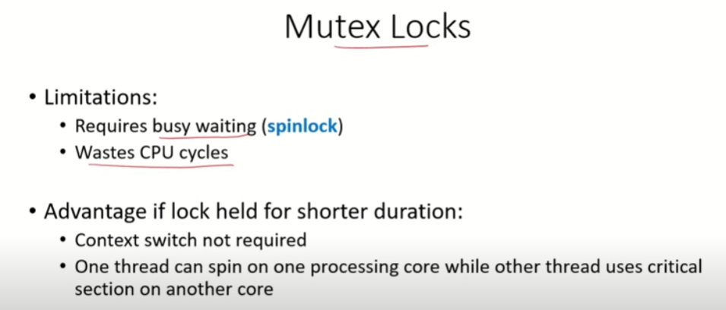

https://www.youtube.com/watch?v=XDIOC2EY5JE
